Dear X,

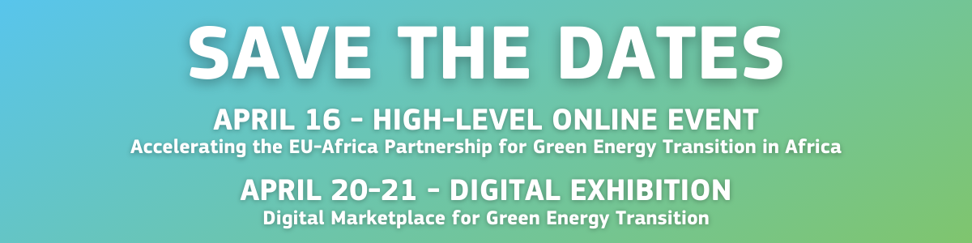We are thrilled to invite you to these EU-Africa Business Forum events that will be hosted by the European Commission, the African Union Commission and the Portuguese Presidency of the European Council, and co-organised with the support of the Africa EU Energy Partnership Secretariat and the Africa Europe Foundation.

On Friday 16th of April
Join us for a high-level discussion on “Accelerating the EU-Africa partnership for green energy transition in Africa”.
The event will feature keynote addresses from:
- Amani Abou-Zeid, African Union Commission's Commissioner for Infrastructure and Energy;
- Augusto Santos Silva, Portugal's Minister of Foreign Affairs;
- Frans Timmermans, European Commission's Executive Vice-President.
It will be followed by a roundtable moderated by Kandeh Yumkella, co-chair of the Africa Europe Foundation Strategy Group on Energy, and will bring together policy makers, development bankers and CEOs from the EU and Africa to discuss the green energy transition on the African continent.

On Tuesday 20 April and Wednesday 21 April
You will discover concrete projects and players that contribute to the green transition in our Digital Marketplace for Green Energy Transition – an online exhibition where you can visit the booths of our various e-exhibitors as well as network with them and other participants. You will find opportunities to further collaborate with key government and business stakeholders and will also be able to participate to conferences and workshops organised by our partners.

Don’t miss out on these events: REGISTER NOW!
Want to become an exhibitor? Click here!

We process your personal data because your partner business organisation has communicated your contact to us. You can unsubscribe from receiving this type of information at any time via an email to [each organisation to insert their own contact email]. In this case, we will delete your name from the contact list and you will not receive any further information on the event. Further information about how we process your personal data is available in the attached privacy statement.

